Final Project:

VidFlixClub Movie Club Website

Genesis Taylor

Management Information Systems

Table of Contents

Section I: Project Description 3

Problem Description 3

Expected Benefits 3

Hardware and Software Requirements 3

Hardware 3

Software 4

System Development Life Cycle 4

Initiation 4

System Concept Development 4

Planning 4

Requirements Analysis 4

Design 4

Development 4

Integration and Test 5

Implementation 5

Operations and Maintenance 5

Disposition 5

Section II: Requirements Definition, Data Models 5

Requirements 5

Major Requirements 5

Minor Requirements 5

Data Flow Diagram 5

Context Flow Diagram 5

Level 1 Data Flow Diagram 6

Entity Relationship Diagram 7

Data Dictionary 7

Movie_picks Table 7

Weeks Table 8

Section III: Prototype 8

Website Screenshots 8

Home 8

Movie Search 9

Amazon Prime 9

Netflix 10

FAQ 10

Contact Us 11

Credits 11

Access Controls 12

System Administrator 12

End User 12

Website 12

Section IV: Implementation, Testing, Installation 12

Implementation & Testing 12

Installation 13

Section V: Future Work 13

# Section I: Project Description

VidFlixClub (http://www.vidflixclub.com) is a movie club where members of the club gather weekly to discuss movies from the streaming services Netflix and Amazon Prime. A member of the club picks tone or two movies weekly, from the streaming site of their choice, to be watched by the group. They are discussed on a designated day and time, usually Sunday. Members have the option to watch as many of the movies as they would like.

## Problem Description

In the past, VidFlixClub used Twitter to discuss the watched movies. They would pick a time to tweet about the movies and while many participated, it became hard for the group to continue. It was not a loss of interest that caused them to stop discussing and rating the movies, but the difficulty in doing so became a burden for the group. Tweets would often get lost among the other tweets on each member’s Twitter feed. They attempted numerous things including hashtags and twitter lists but neither option worked.

In addition, the timing became an issue for some. It conflicted with the schedules of many tweeters and some simply forgot about it. While those that were present continued on, others were left out of the conversation. There was never a time where the entire group could have a proper discussion of the movies.

Many members lost track of which movies were to be watched. A list was tweeted, some added it to their favorites list, and other did not. There were also those who wanted to re-watch past movies that had gotten great reviews, and those who joined the group late, that wanted to watch the same movies. Neither could be done since there was no permanent list of the movies.

## Expected Benefits

What is proposed is a website that will give the club members a way to discuss the movies through a comments section and it will also host a database that will house a list of the movies. The lists will be structured in a way so that the users of the site can view the movies along with their streaming service, week it was suggested, genre, MPRS rating, link to the movie on its streaming site, and description.

## Hardware and Software Requirements

### Hardware

* For setting up the site, a laptop with Internet access is preferred.
* Multiple devices to test if site is mobile-friendly.
* For using the site, any device with Internet access. This includes laptops, smartphones, PCs, and tablets.
* Server to host the database, website information, and any software installed onto the site.

### Software

* Multiple browsers (Chrome, Safari, Firefox) to test if the site works properly on each.
* A dashboard that permits management of many different software for site.
* Test editing software for any programming that is to be done.
* A relational database system that is to be used to create the database.
* Email system

## System Development Life Cycle

Below is the SDLC as it related to this project:

### Initiation

Genesis Taylor initiated the project. The project was formed to handle the way members of the movie club discussed movies. It was seen as a way to make discussions better and give users a way to view previously watched movies.

### System Concept Development

Them project team worked to figure out the feasibility, cost and benefit of the project.

### Planning

Research was done to gather what exactly was possible. From that a domain, hosting site, and creation tool was gathered.

### Requirements Analysis

User wants and needs were gathered along with the functional requirements of the project. It was established that a website with a database background would be the best method for establishing this project.

### Design

The team created a baseline plan to facilitate the planning phase. The baseline plan can be found in the folder for this project. User requirements were finalized and the design for the website was considered from this. It was established that a user friendly website that allowed users to access basic things such as search, discussions, and email was needed. From that, creation methods were researched, created, and obtained.

### Development

We took the elements wanted for design and developed a system using Hostgator, databases, and Wordpress along with a theme and plugins which are future discussed in the technological details document.

### Integration and Test

After each feature was integrated into the system, it was tested and any errors were fixed.

### Implementation

As a follow up to the previous phase, all errors and issues were addressed.

### Operations and Maintenance

Ongoing

### Disposition

Backups are constantly being done for security reason and to have the latest version of things for the end phase and next step of this system.

# Section II: Requirements Definition, Data Models

## Requirements

### Major Requirements

* The VidFlixClub website must have access points for both users and administration. The proper privileges must be set for each to secure the site.
* The site needs to be compatible with multiple devices and browsers.
* The site must be able to withstand multiple users at a time.
* The site must allow users the ability to easily comment on movie discussions.
* The site must have protection against spam and malicious attacks.

### Minor Requirements

* The site should offer users the ability to search for movies.
* The site should have a log on system
* The site should be available 90% of the time or more.
* The site must look appealing.

## Data Flow Diagram

### Context Flow Diagram

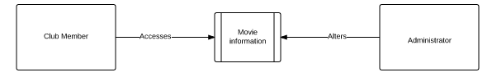

### Level 1 Data Flow Diagram

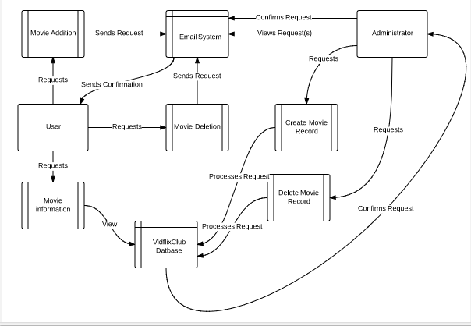

## Entity Relationship Diagram

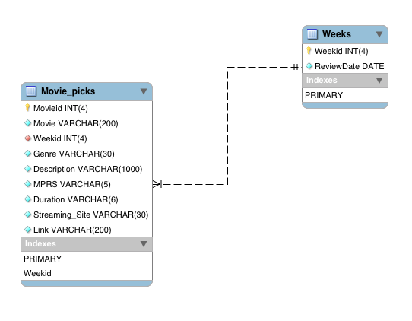

## Data Dictionary

|  |  |  |  |  |  |
| --- | --- | --- | --- | --- | --- |
|  | Movie_picks Table | | | | |
| **Column** | | **Type** | **Validation Range** | **Null** | **Description** |
| Movieid (PK) | | Int(4) | (0-9) | No | The unique identification number, primary key for the table, and way of identifying the movie. |
| Movie | | Varchar(200) |  | No | The name of the movie. |
| Weekid(FK) | | Int(4) | (0-9) | No | The id that identifies the week in which the movie from the Movie_picks table would be watched and discussed by the movie club. This is also the foreign key for the table and references the ‘Weeks” table. |
| Genre | | Varchar(30) |  | No | The genre or category that the movie fits in to |
| Description | | Varchar(1000) |  | No | A brief description of the movie. |
| MPRS | | Varchar(5) |  | No | The motion picture rating system rating of the movie. |
| Duration | | Varchar(6) |  | No | The length of the movie. The letter ‘h’ indicates the amount of hours while ‘m’ indicates the amount of minutes. |
| Streaming_Site | | Varchar(30) |  | No | This is the streaming site location |
| Link | | Varchar(200) |  | No | A direct link to the movie from the streaming site. |

The Movie_picks table is the main table of the database. It lists all of the information about the movies.

|  |  |  |  |
| --- | --- | --- | --- |
| Weeks Table | | | |
| **Column** | **Type** | **Null** | **Description** |
| Weekid (PK) | Int(4) | No | The id that identifies the week in which the movie from the Movie_picks table would be watched and discussed by the movie club. This is also the foreign key for that table. |
| ReviewDate | date | No | The specific date of which the group will discuss the movie. |

# Section III: Prototype

## Website Screenshots

Below are screenshots of pages the website. There are explained in better detail in the VidFlixClub User Guide

### Home

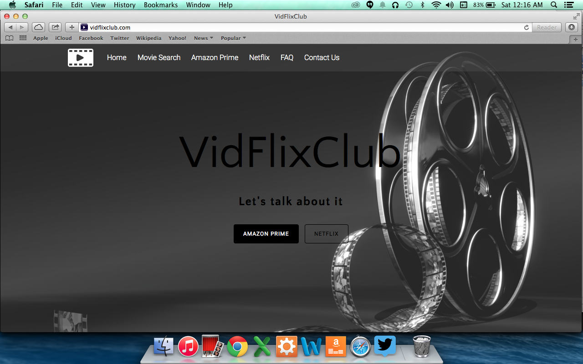

### Movie Search

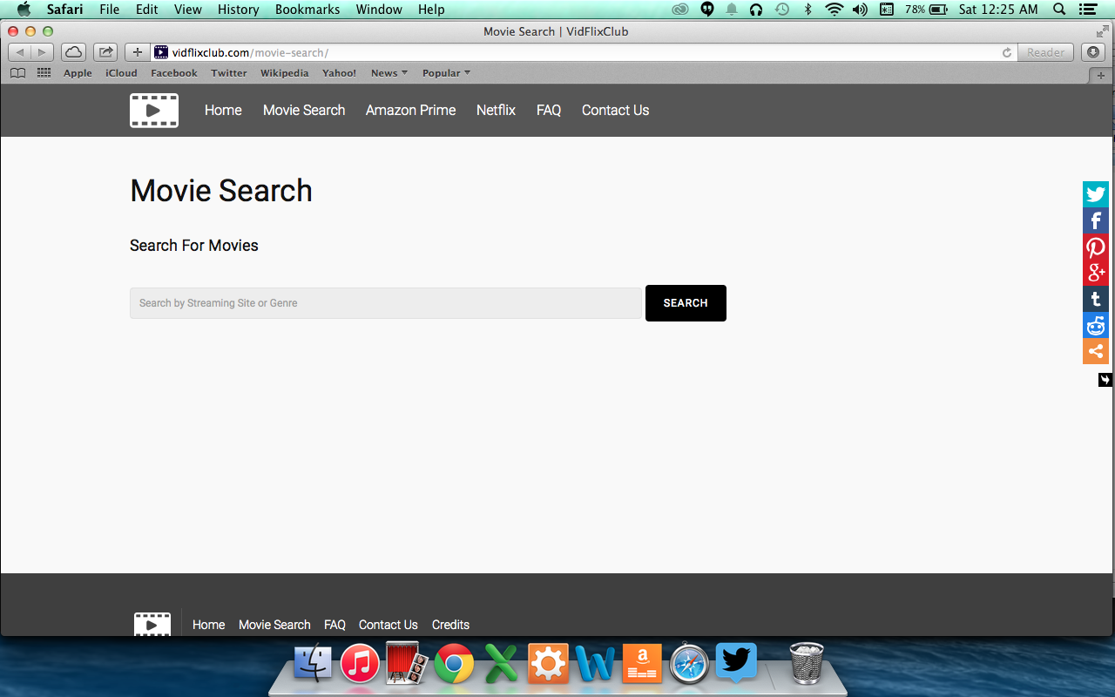

### Amazon Prime

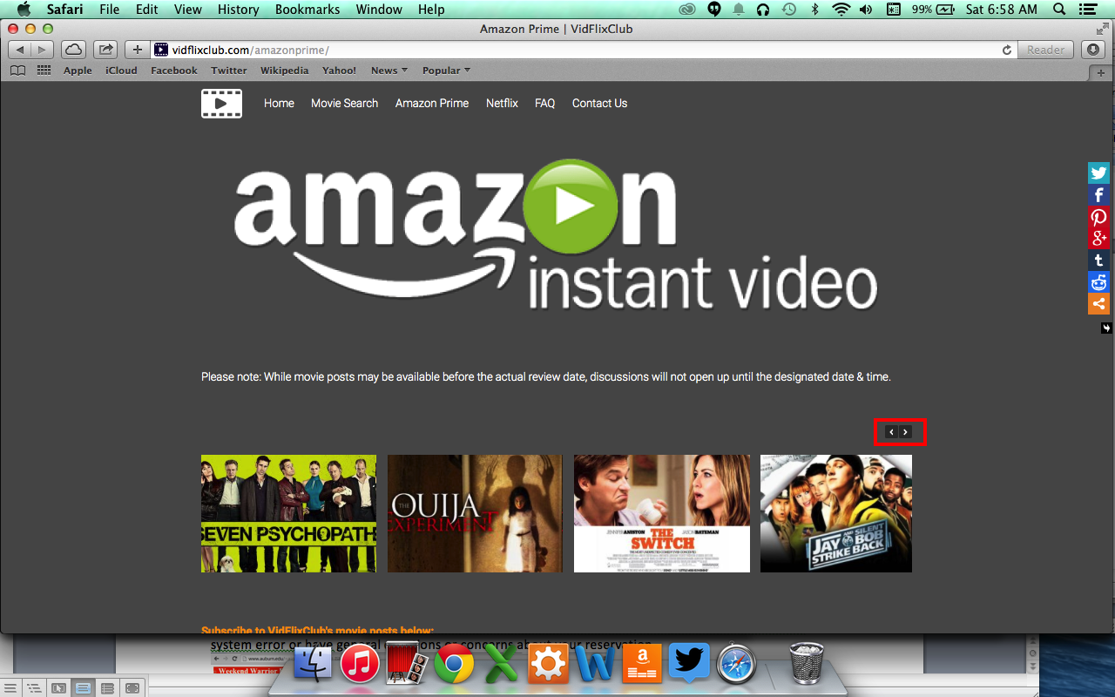

### Netflix

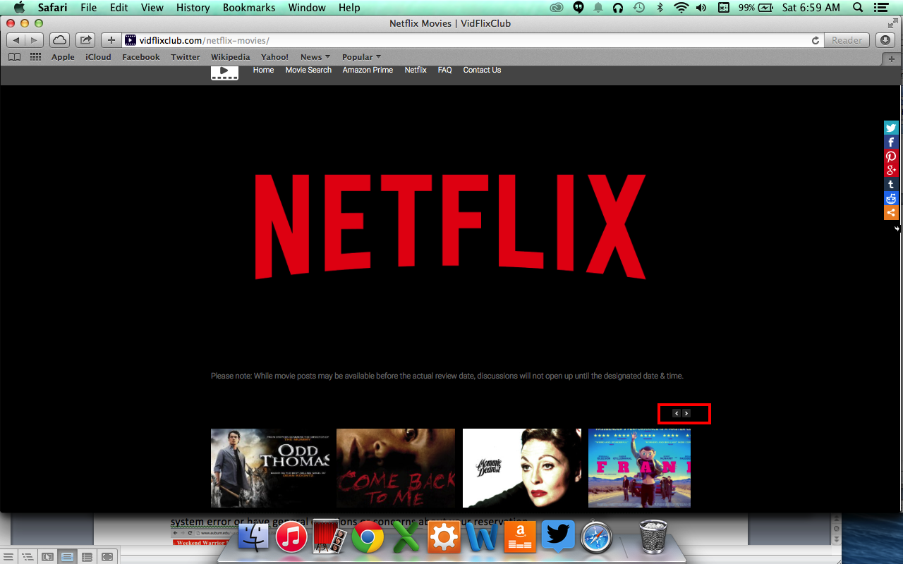

### FAQ

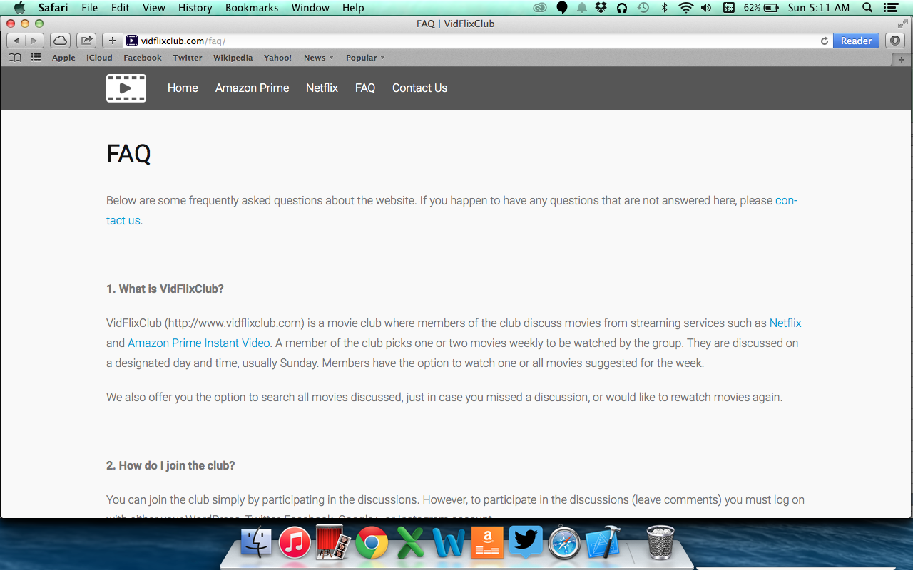

### Contact Us

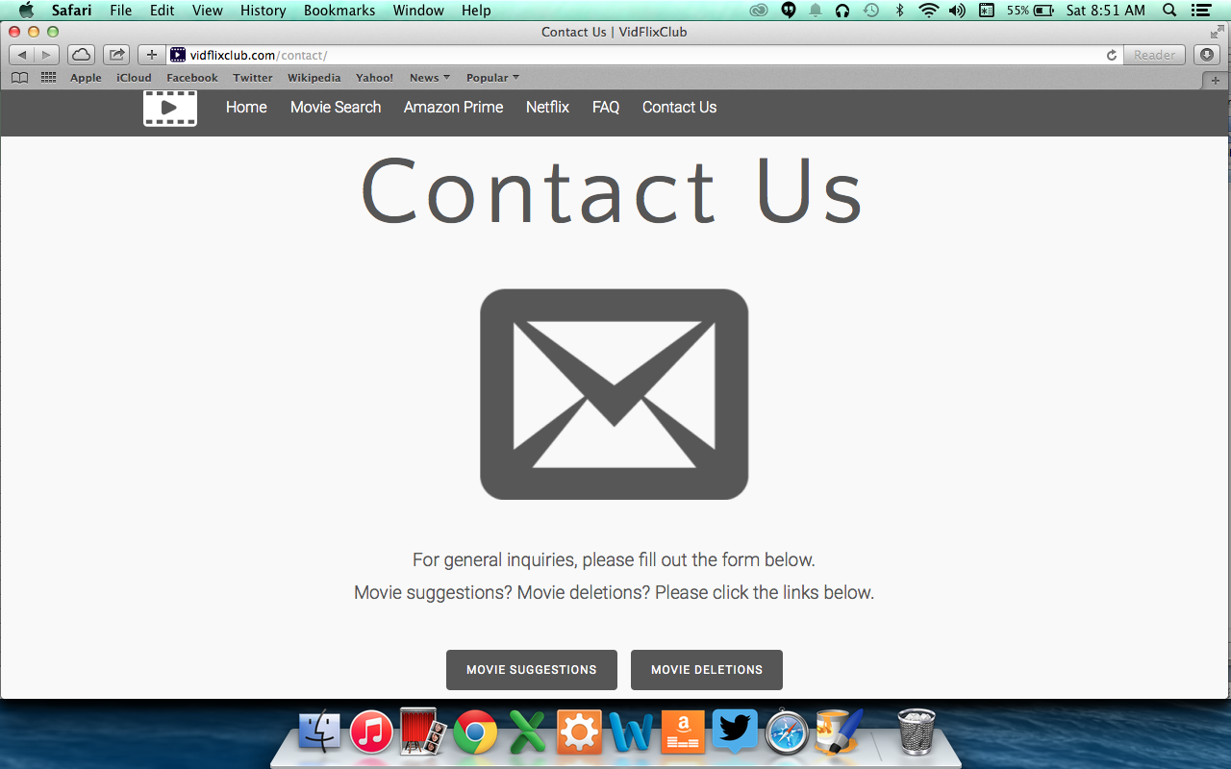

### Credits

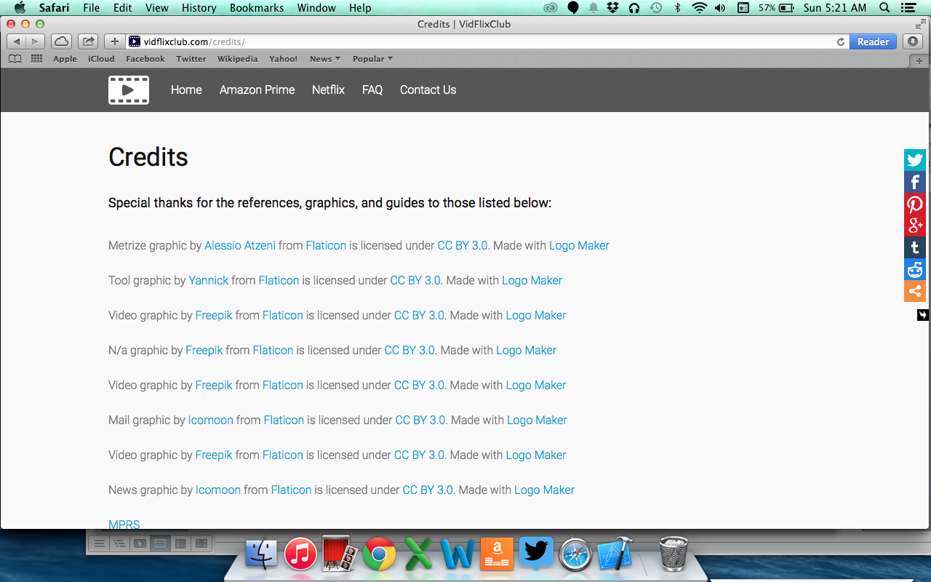

## Access Controls

### System Administrator

* The system administrator must be able to modify all movie data in the database.
* The system administrator must be able to modify all pages and posts on the website.
* The system administrator must be able to ban abusive users.
* The system administrator must be able to receive and respond to emails from users.

### End User

* The end user must be able to search the database for movies
* The end user must be able to comment on movie posts.
* The end user must be able to email the site administrator.
* The end user must be able to request movies.

## Website

<http://www.vidflixclub.com>

# Section IV: Implementation, Testing, Installation

## Implementation & Testing

The implementation of this system occurred in the following steps:

1. The domain for the system was purchased through Godaddy.com.
2. The hosting space at Hostgator.com was obtained and the domain was setup on that site.
3. The background needs for the site were setup through the Hostgator hosting site. This included Cpanel, which contained the database space setup through MyPhpAdmin, email system, and site creation tool, Wordpress.
4. The movie data was created through Excel then transferred to MYSQL Workbench before being uploaded to the database on the hosting site through MyPhpAdmin.
5. The website was designed with the help of Wordpress, various plugins, and specific PHP coding. See the Technical Details document for more information.

The system was tested after every implementation step and the proper steps were taken to fix issues as they arose.

## Installation

Installs to the system included installing MYSQL and the MYSQL workbench onto the system creator’s computer, installing the latest version of Wordpress through Hostgator, and the installation of various themes, documents, and plugins. See the Technical Details document for more information.

# Section V: Future Work

Future work on the site includes making movie requests and deletions an easier process for users. We will look to include television series and other streaming sites such as Hulu, HBOGo, or any others that may be of interest. There is also the possibility of moving the system from being a Wordpress creation.